**Lesson 2 Getting Started**

# Start

Power Supply method:

1. Using USB cable to connect to computer USB port or to USB charger.

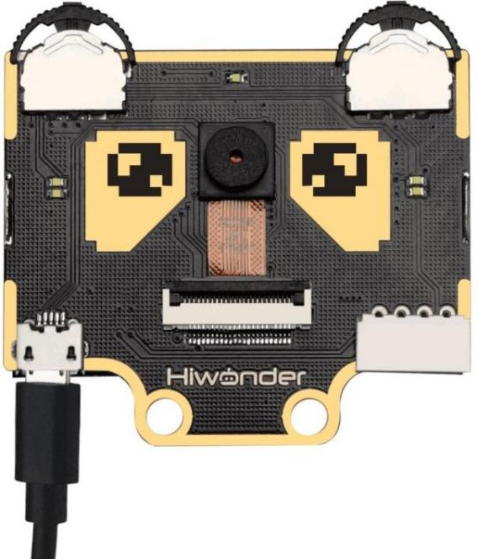

1. Using 4Pin connector to connect to Controller Expansion Board e.g. Hiwonder micro:bit expansion Board, Arduino Expansion Board.

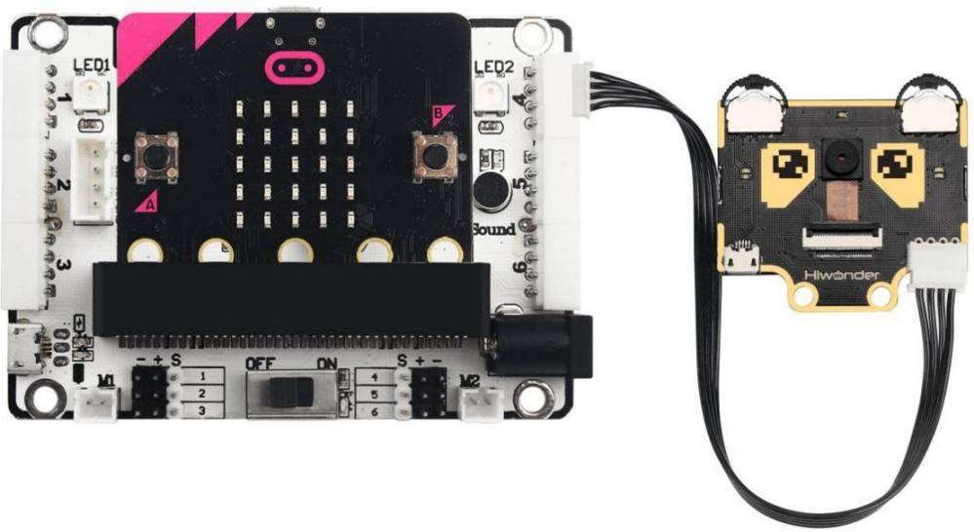

Important Note on Power Supply:

a. Do not exceed 5V in power supply. Use only charger or battery power not more than 5V.

b. Ensure consistent voltage supply or WonderCam will perform erratically.

**2. Operating Guide**

2.1 Basic Operation

When start up, default display and function will be on Color Recognition.

Located on top left and right of WonderCam are two function buttons. Switch

between menu or functions by pushing the button left or right, press button

downward to execute selection.

The top left function button is menu navigation, top right function button is to select the menu functions.

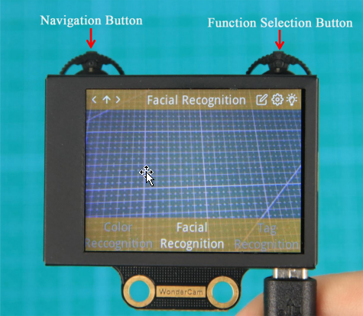

In following example, move to Facial Recognition function.

a. Navigation Button: Move Navigation Left/ Right to switch menu.

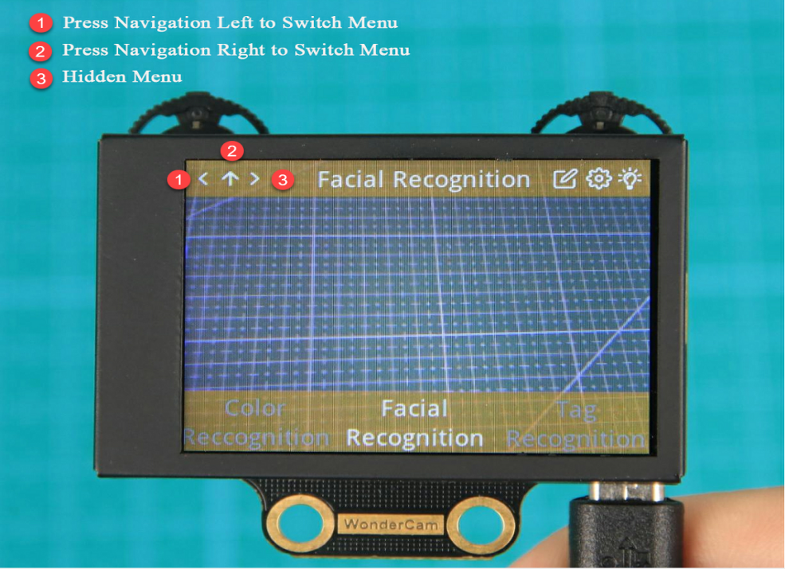

When navigating and switching menu, wait for Progress Circle to disappear to

complete the command.

b. Function Button:Settings for each menu selected.

Please note: the function setting icons will change according to menu selected.

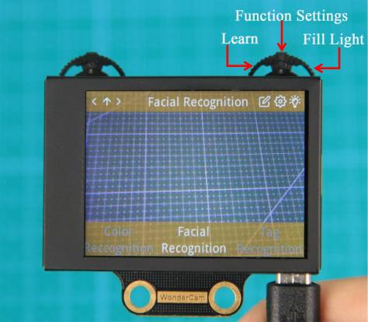

Push Function Button to the Right direction to switch Fill Light to On/Off.

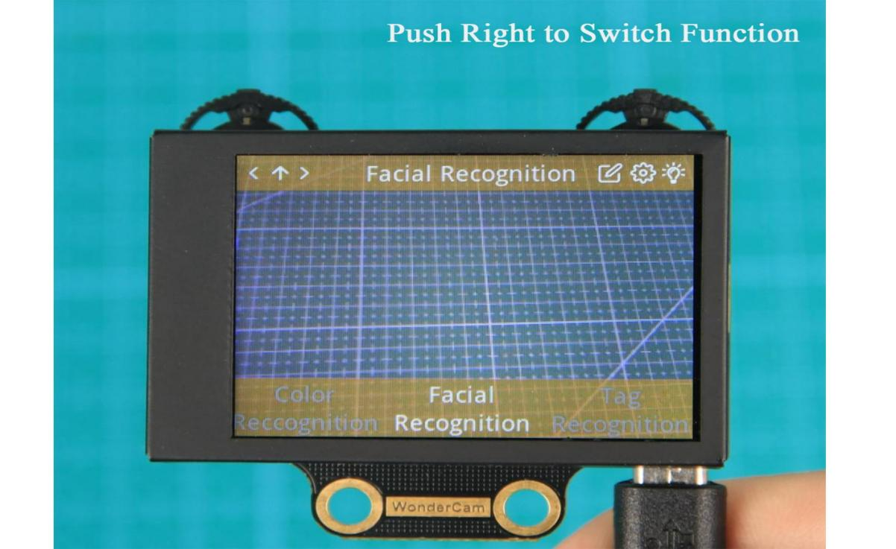

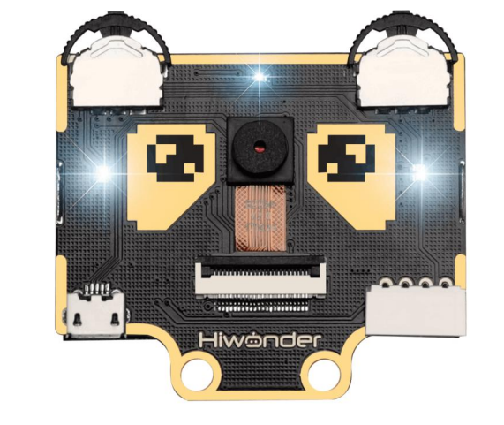

2.2 Function Settings

Certain function settings is configurable. Example,Face Recognition can configure Detection Threshold level, NMS Threshold etc. The functions can be configured when a Gear icon display on top right screen.

Step 1: Configuration settings

In Face Recognition menu, Press Function Button downward to select Gear icon function to access threshold configuration interface.

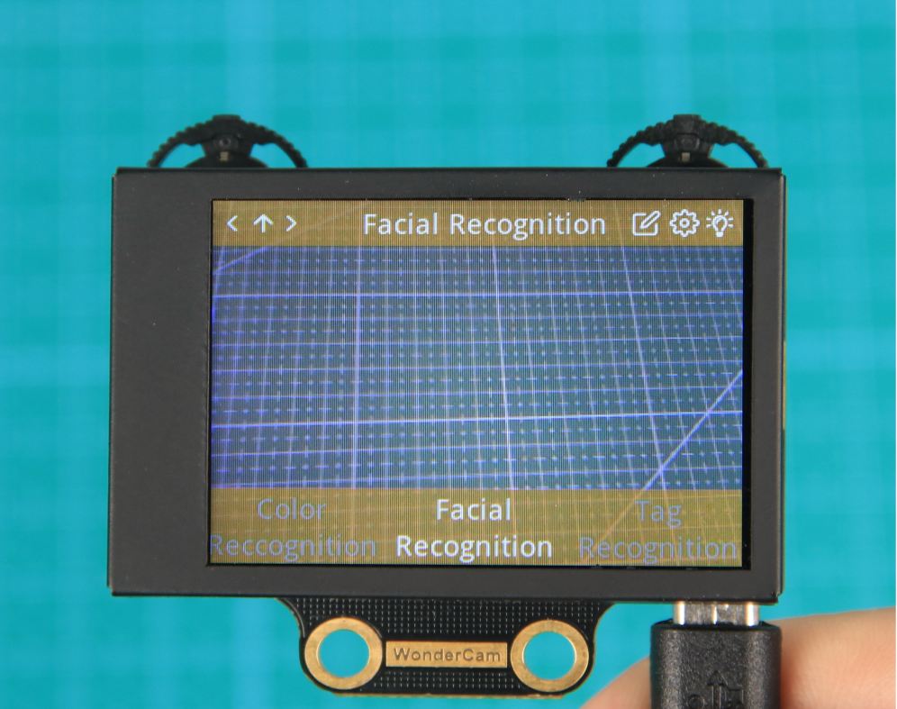

Step 2: Settings

Push button left/right to see the types of threshold to configure.

Press function button down again to select the threshold type.

Push button left/right to adjust selected threshold level.

When done, press function button downward to select OK. Interface will return to previous menu.

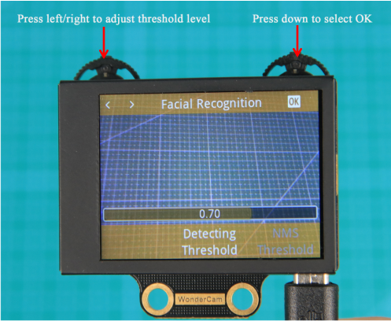

Step 3: Exit setting, back to main menu

Press Navigation button downward on <x> icon to exit. Move Navigation button left or right direction to toggle between "Yes" or "No" to save new settings. Press Function button downward to select.

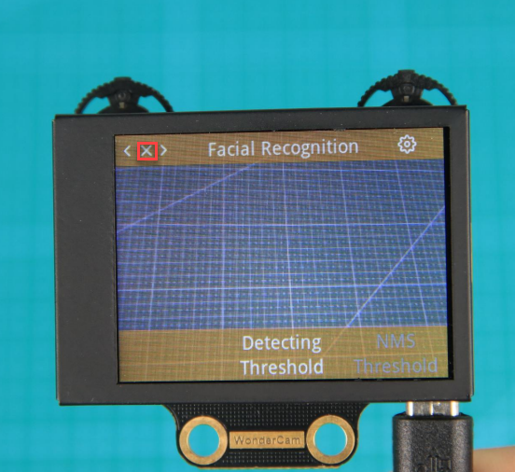

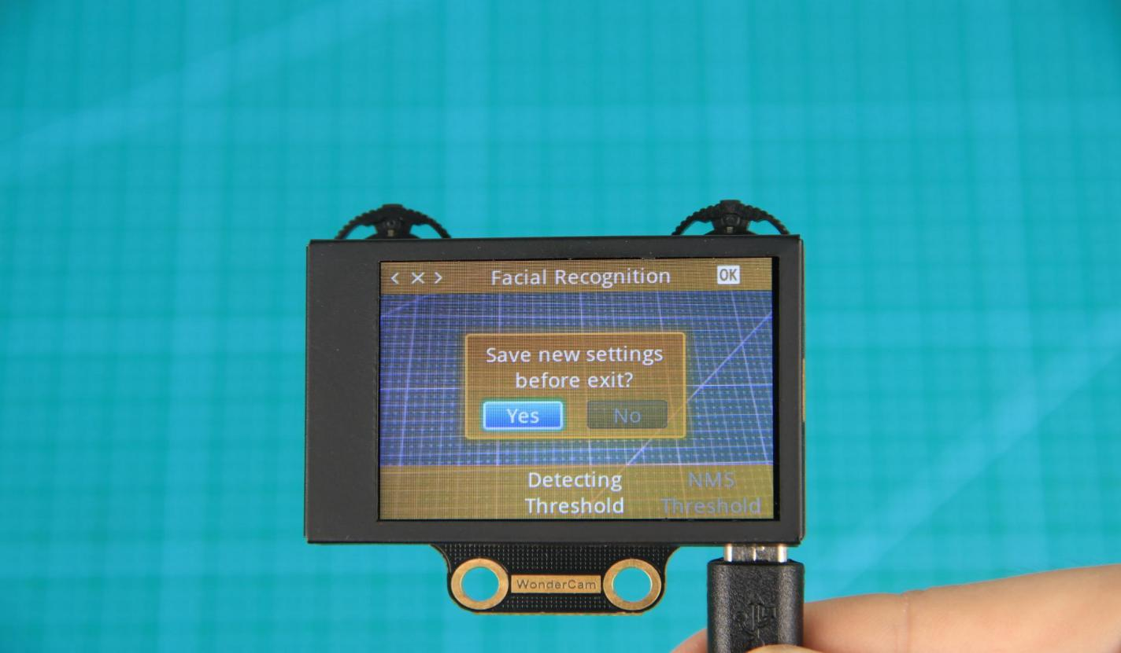

2.3 System Settings

Apart from individual function settings, WonderCam device setting is configurable as well.

Step 1: Enter System Setting

On main menu, move Navigation button to Right direction until last option

"System Settings". Press Function button downward on Gear icon to enter

system settings mode.

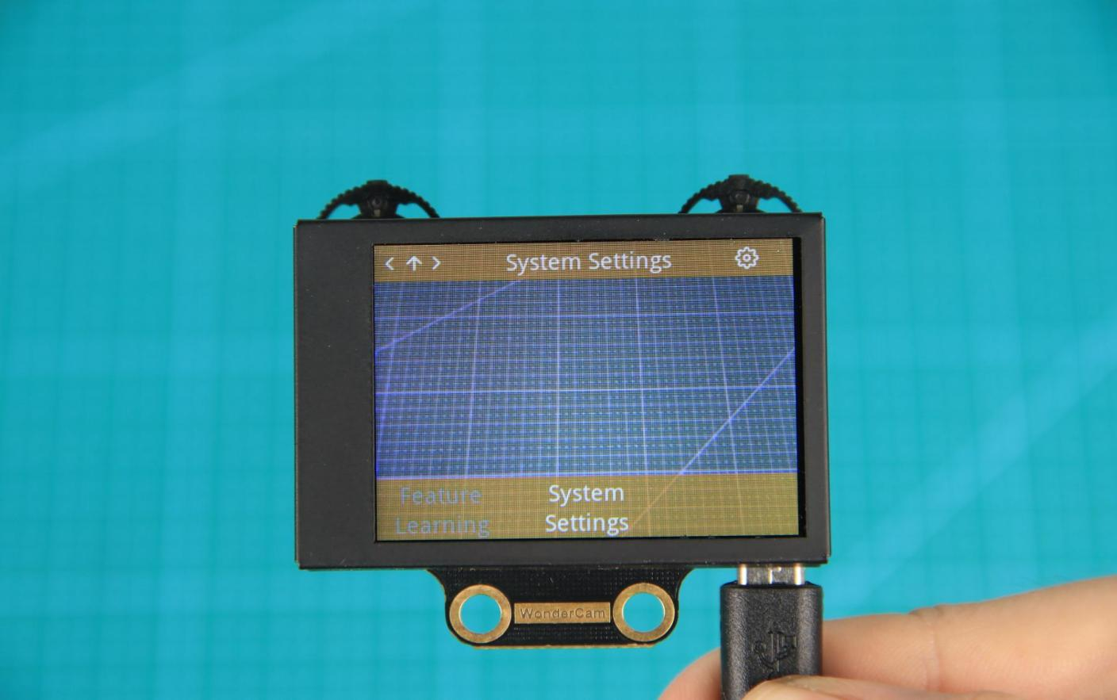

Step 2: Settings

* Display Brightness - to adjust display brightness.
* Fill Light Brightness - to adjust fill light brightness.
* Hide Menu Timeout - to set timeout on display of menu.

If set at 30, after 30 seconds idle from operation, the menu will be hidden.

* I2C Address - to set WonderCam I2C communication protocol address.

Default setting is 0x32.

* Language - to set system language.

Current version supports English and Simplified Chinese.Upon setting confirmation, WonderCam will restart for new setting to take effect.

**3. Understanding Coordinate**

Understanding the coordinate system will benefits the comprehension of how WonderCam process data output which will be mention in the later lessons.

See image below on the assigned on x and y axis.

